

Lab Manual- Build and Register Features in a Feature Store using Feast

Prepared for:

Date: 18th Nov 2025

Prepared by:
Document Name: Lab Manual Document Number MLOps
Contributor:

Contents
1. Lab Description 2
2. Business Scenario 3
3. Lab Step 3
1. Step 1 Create Project Folder 3
2. Step 2 Create Python Virtual Environment 3
3. Step 3 – Create the Dataset 6
4. Step 4 – Create Feature Engineering Program 7
5. Step 5 – Create AI Training Program 10
6. Step 6 – Execute AI Training 11
7. Step 11 – Create Prediction Program 12

Lab Description
In this lab, you will build a simple Feature Store for Vodafone's Billing Assurance AI system. You will create business features from raw billing data, register them in a Feature Store using Feast, and retrieve them for machine learning models. This demonstrates how the same trusted features can be reused across multiple AI applications, ensuring consistency between model training and production.

- Step 1: Read the Feature Store (customer_features.csv).
- Step 2: Add the target column (BillingStatus) that the model should learn.
- Step 3: Select the engineered features for training.
- Step 4: Select the output (target) column.
- Step 5: Create a Decision Tree machine learning model.
- Step 6: Train the model using the Feature Store.
- Step 7: Create a new customer record with feature values.
- Step 8: Ask the trained model to predict the customer's billing status.
- Step 9: Display a user-friendly prediction.

Business Scenario
Vodafone receives millions of billing transactions every day.

Rather than calculating customer features separately for every AI model, Vodafone stores these features in a Feature Store.
This allows
- Billing AI
- Fraud Detection
- Customer Churn Prediction
to reuse exactly the same features.

Lab Step

Step 1 Create Project Folder
- Description
Create a new folder that will contain the complete Feature Store project.

mkdir FeatureStoreLab

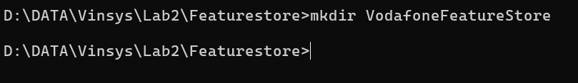

Step 2 Create Python Virtual Environment

Open Project folder VS Code.
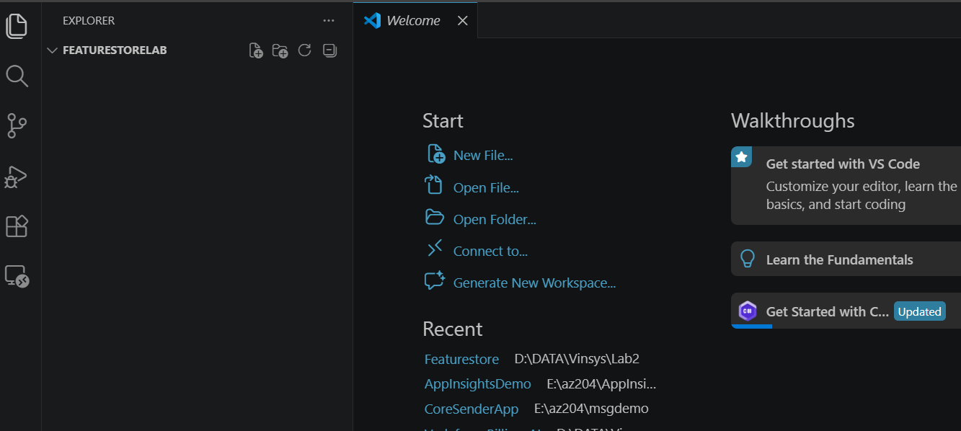

Open Terminal in VS Code
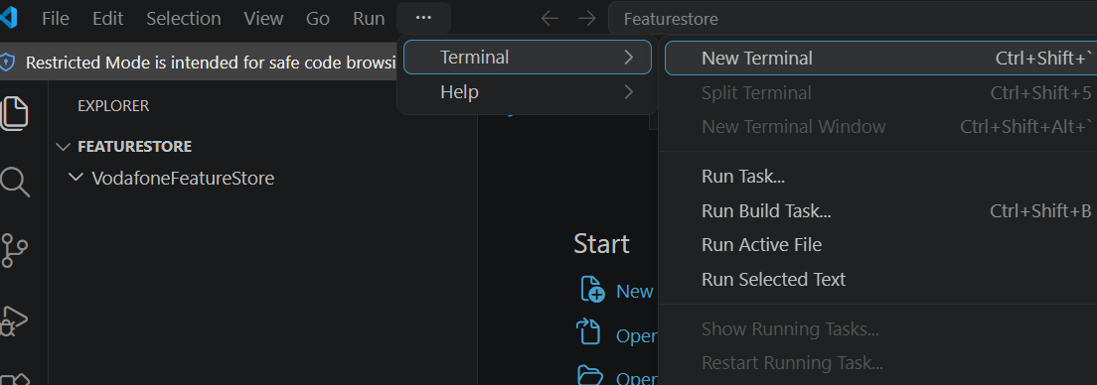

Ensure terminal editor should be PowerShell
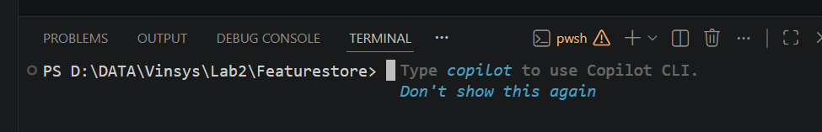

Create Virtual Environment
A Python virtual environment is like a separate mini Python setup inside your project. Create an isolated Python environment so project dependencies do not affect other Python projects.

py -m venv labenv

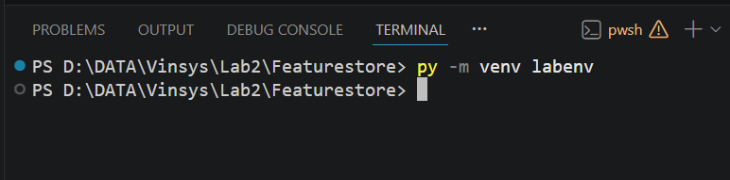

Activate the virtual environment
What activation does:
- Tells system: “Use this environment”
- Installs packages locally (not globally)

.\labenv\Scripts\Activate.ps1

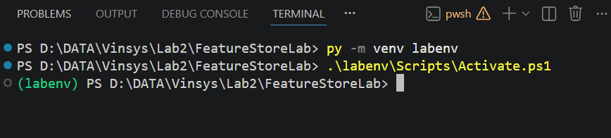

Install Required Package
Install the libraries required for data processing, model training, dataset versioning, and experiment tracking.

Install Feast and Pandas.
- Pandas → Read CSV files
- Scikit-learn → Builds the AI model.
pip install pandas scikit-learn
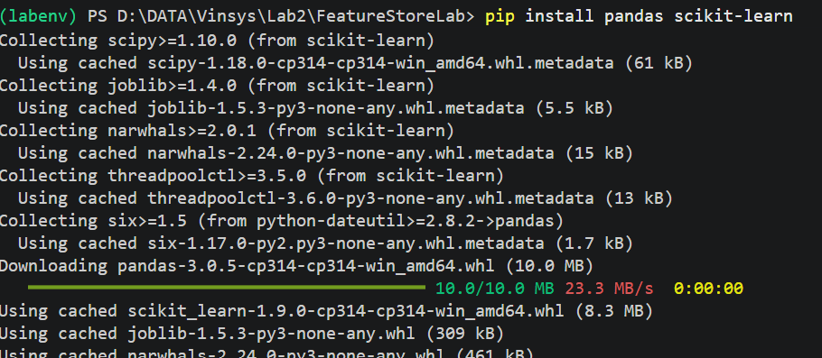

Verify the Installation

pip list

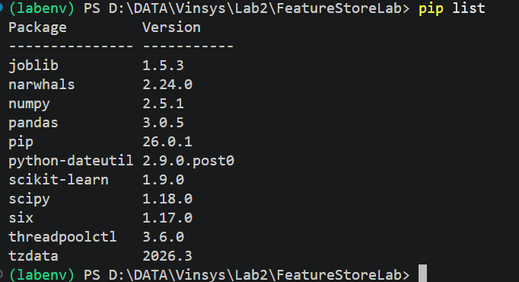

Create Project Folders
Organize the project into separate folders.

mkdir data
mkdir scripts
mkdir models

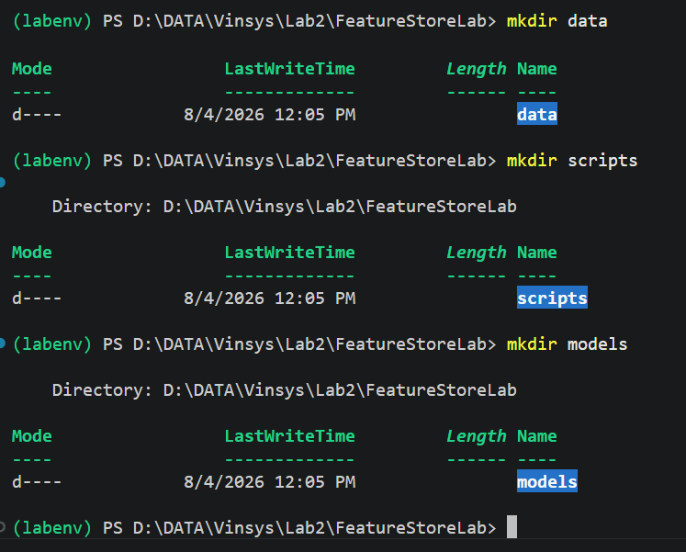

Step 3 – Create the Dataset

Create a dataset inside Data Folder
billing_data.csv

CustomerID,DataGB,Calls,BillAmount
1001,10,120,800
1002,6,90,450
1003,15,160,1200
1004,8,110,650
1005,20,180,1500
1006,12,140,900
1007,5,70,350
1008,18,190,1450

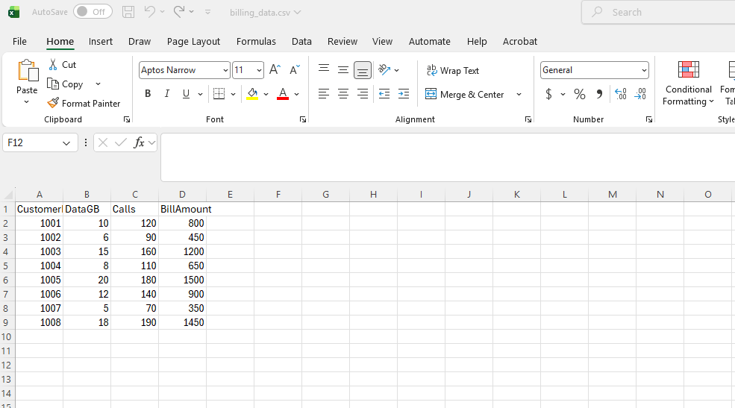

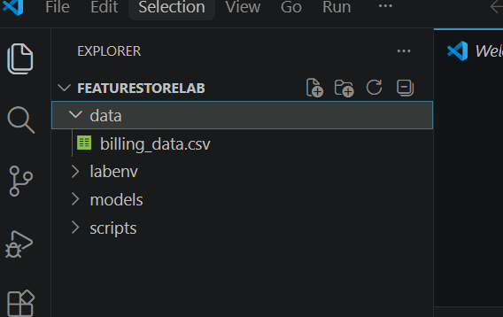

Step 4 – Create Feature Engineering Program
Generate business features from raw billing data. The program reads the billing dataset and creates reusable AI features.
Create new file under Script folder
create_features.py
# Import the Pandas library
import pandas as pd

# Read the Vodafone billing dataset
df = pd.read_csv("../data/billing_data.csv")

# Create business features

# Feature 1: Monthly Data Usage
df["MonthlyDataUsage"] = df["DataGB"]

# Feature 2: Average Call Count
df["AverageCallCount"] = df["Calls"]

# Feature 3: Monthly Bill
df["MonthlyBill"] = df["BillAmount"]

# Feature 4: Usage Billing Ratio
df["UsageBillingRatio"] = df["DataGB"] / df["BillAmount"]

# Save the generated features
df.to_csv("../data/customer_features.csv", index=False)

print("Feature Store Created Successfully")

print(df)

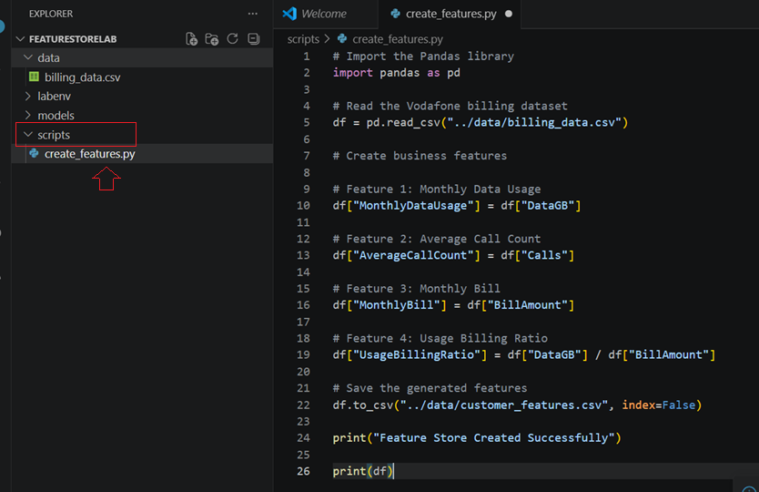

4.1 Execute the Feature Engineering Program
Create the Feature Store.

cd scripts

python create_features.py

Expected Output
Feature Store Created Successfully

New File Created
FeatureStoreLab
│
└── data
customer_features.csv
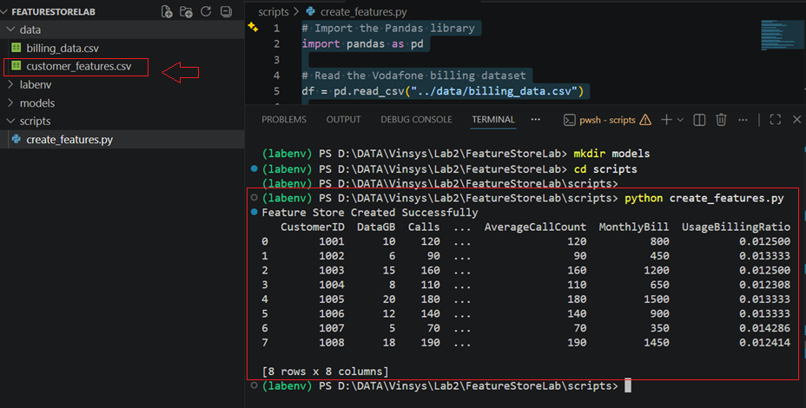

4.2 View the Feature Store
Verify that the features were created successfully.

Open
FeatureStoreLab
│
└── data
customer_features.csv
Expected
CustomerID | MonthlyDataUsage | AverageCallCount | MonthlyBill | UsageBillingRatio
1001 | 10 | 120 | 800 | 0.0125

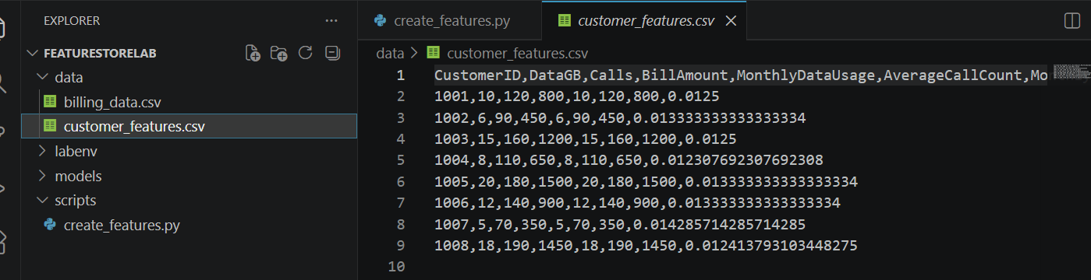
Note
This CSV file is acting as our Feature Store.
It stores reusable features that multiple AI models can use.

Step 5 – Create AI Training Program
Create training programs under Script Folder

train_model.py
Paste the AI training code.
import pandas as pd

from sklearn.tree import DecisionTreeClassifier

# Read Feature Store
df = pd.read_csv("../data/customer_features.csv")

# Create target column
df["BillingStatus"] = [0, 0, 1, 0, 1, 0, 0, 1]

# Select Features
X = df[
[
"MonthlyDataUsage",
"AverageCallCount",
"MonthlyBill",
"UsageBillingRatio",
]
]

# Target
y = df["BillingStatus"]

# Train AI Model
model = DecisionTreeClassifier()

model.fit(X, y)

print("AI Model Trained Successfully")

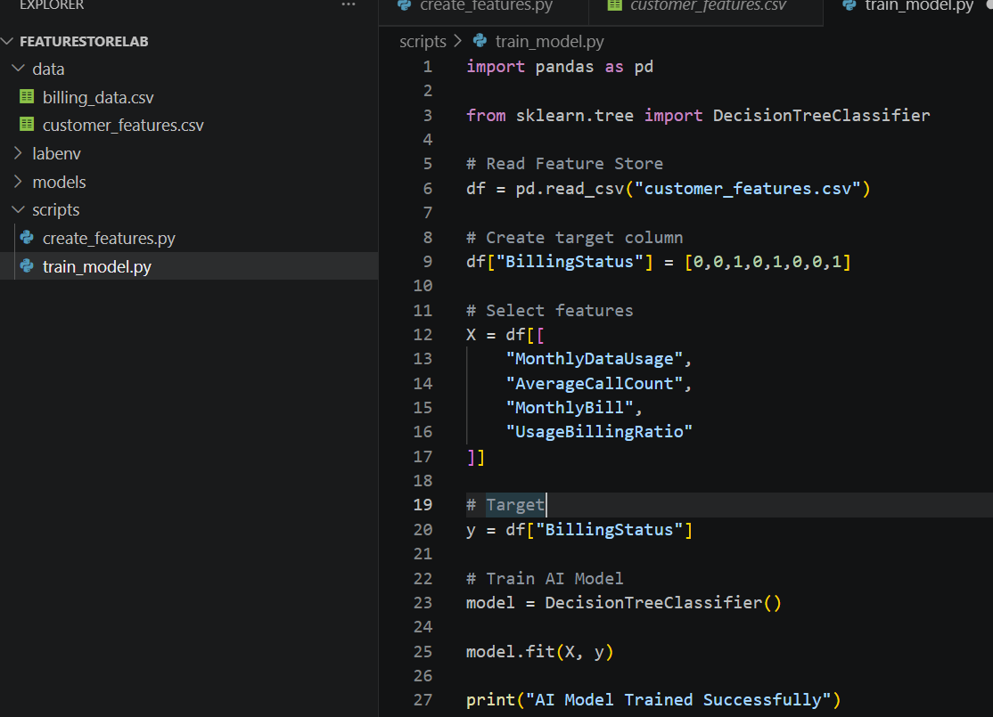

Step 6 – Execute AI Training
Location

FeatureStoreLab
│
└── scripts
Execute
python train_model.py

Expected Output
AI Model Trained Successfully
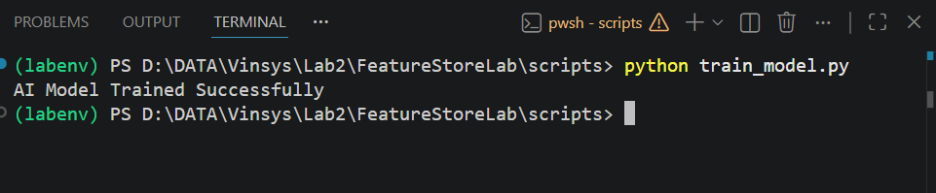

Step 11 – Create Prediction Program
File Location
FeatureStoreLab
│
└── scripts
predict.py
Create
predict.py
Paste the prediction program.

# ---------------------------------------------------------
# Import Required Libraries
# ---------------------------------------------------------

# Pandas is used to read and work with CSV files
import pandas as pd

# DecisionTreeClassifier is a Machine Learning algorithm
# used to classify data into different categories.
from sklearn.tree import DecisionTreeClassifier

# ---------------------------------------------------------
# Step 1: Read the Feature Store
# ---------------------------------------------------------

# Load the engineered features from the Feature Store
df = pd.read_csv("../data/customer_features.csv")

# ---------------------------------------------------------
# Step 2: Create the Target Column
# ---------------------------------------------------------

# BillingStatus is the value we want the AI model to predict.
# 0 = Normal Billing
# 1 = Billing Anomaly

df["BillingStatus"] = [0, 0, 1, 0, 1, 0, 0, 1]

# ---------------------------------------------------------
# Step 3: Select Input Features
# ---------------------------------------------------------

# These are the business features used to train the AI model.

X = df[[
"MonthlyDataUsage",
"AverageCallCount",
"MonthlyBill",
"UsageBillingRatio"
]]

# ---------------------------------------------------------
# Step 4: Select the Target Variable
# ---------------------------------------------------------

# This is the output the model will learn to predict.

y = df["BillingStatus"]

# ---------------------------------------------------------
# Step 5: Create the Machine Learning Model
# ---------------------------------------------------------

# Create a Decision Tree Classification model.

model = DecisionTreeClassifier()

# ---------------------------------------------------------
# Step 6: Train the AI Model
# ---------------------------------------------------------

# Train the model using the Feature Store data.

model.fit(X, y)

print("AI Model Trained Successfully")

# ---------------------------------------------------------
# Step 7: Create a New Customer Record
# ---------------------------------------------------------

# New customer feature values for prediction.
# Using a DataFrame keeps the same feature names used during training.

new_customer = pd.DataFrame({
"MonthlyDataUsage": [12],
"AverageCallCount": [130],
"MonthlyBill": [900],
"UsageBillingRatio": [0.013]
})

# ---------------------------------------------------------
# Step 8: Predict the Billing Status
# ---------------------------------------------------------

prediction = model.predict(new_customer)

# ---------------------------------------------------------
# Step 9: Display the Result
# ---------------------------------------------------------

if prediction[0] == 0:
print("Prediction : Normal Billing")
else:
print("Prediction : Billing Anomaly Detected")

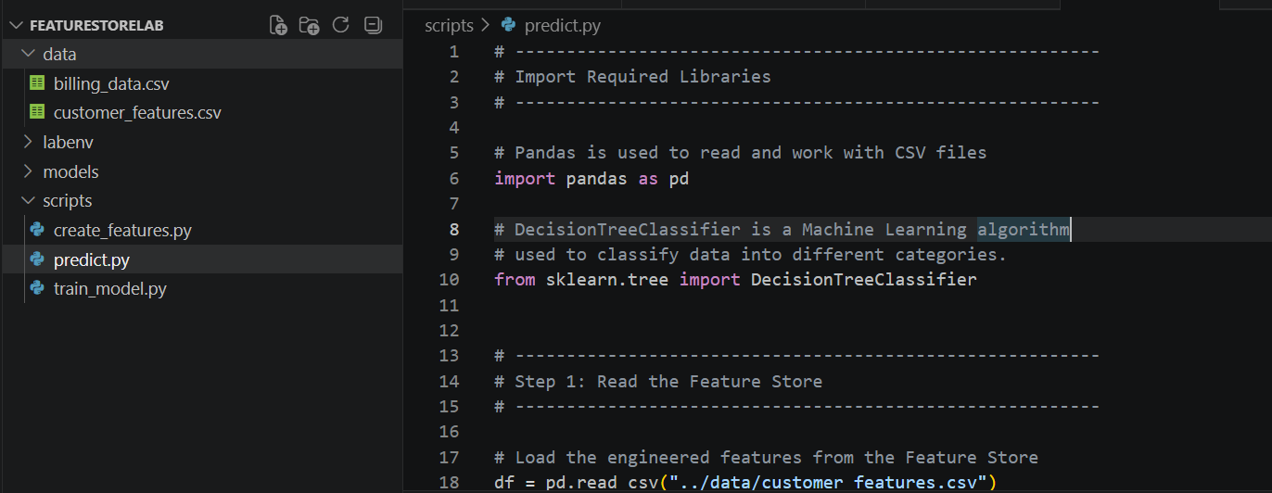

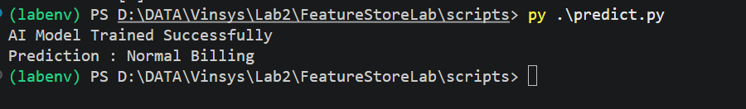

Create Another Prediction program with change data

new_customer = pd.DataFrame({
"MonthlyDataUsage": [19],
"AverageCallCount": [185],
"MonthlyBill": [1480],
"UsageBillingRatio": [0.0128]
})

